
North Bengal International University

Assignment: 01
Assignment Name: Subnetting calculation

Subject : Computer Network
Subject Code : CSE 0612-3232

Submitted By:
Name : Md. Tanvir Rahman Pranto
Dept : CSE-26
Roll : 0712340012101005
Semester : 3rd Year, 5th semester.

Submitted To:
Name : Dr. Md. Rabiul Islam
Designation : Lecturer
Dept : CSE
Date :

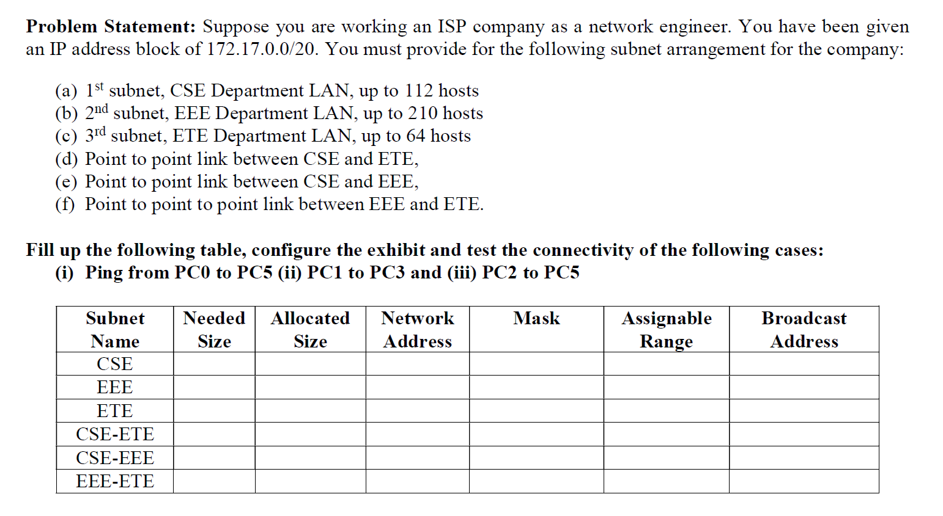
Solve: 172.17.0.0/20

20 = 11111111 . 11111111 . 11111100 . 00000000

Step-1: Sort (descending order) the number of subnets:
- 1st subnet, EEE Department lan = 210+2 = 212
- 2nd subnet, CSE department lan = 112+2 = 114
- 3rd subnet, ETE Department lan = 64+2 = 66
- Point to point link between CSE to ETE = 2+2 = 4
- Point to point link between CSE to EEE = 2+2= 4
- Point to point link between EEE to ETE = 2+2= 4

Step-2: 172.17.0.0/20

2⁰=1 2¹=2 2²=4 2³=8 2⁴=16 2⁵=32 2⁶=64 2⁷=128 2⁸=225

Host <= 2^{n} N=8

Step-3:
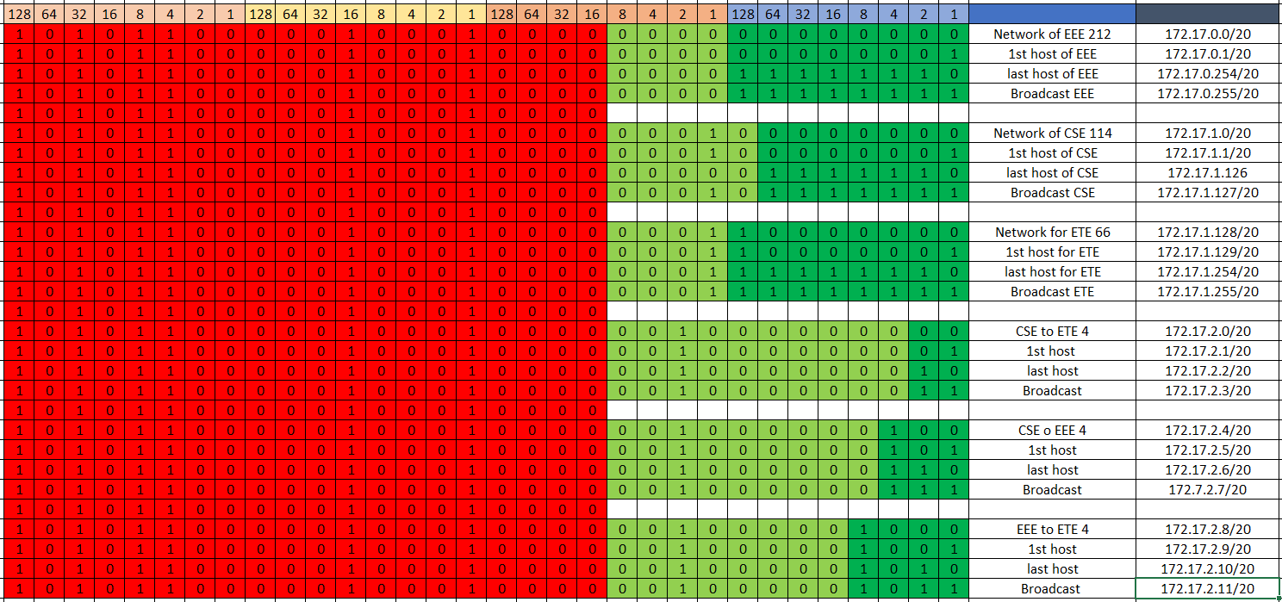

Subnet Name | Needed Host | Allocate Host | Network Address | Mask | Assigned Range | Broadcast Address
EEE | 210 | 212 | 172.17.0.0/20 | 255.255.255.0 | 172.17.0.1 - 172.17.0.254 | 172.17.0.255
CSE | 112 | 114 | 172.17.1.0/20 | 255.255.255.128 | 172.17.1.1 - 172.17.1.126 | 172.17.1.127
ETE | 64 | 66 | 172.17.1.128/20 | 255.255.255.128 | 172.17.1.129 - 172.17.1.254 | 172.17.1.255
CSE to ETE | 2 | 4 | 172.17.2.0/20 | 255.255.255.252 | 172.17.2.1 - 172.17.2.2 | 172.17.2.3
CSE to EEE | 2 | 4 | 172.17.2.4/20 | 255.255.255.252 | 172.17.2.5 - 172.17.2.6 | 172.17.2.7
EEE to ETE | 2 | 4 | 172.17.2.8/20 | 255.255.255.252 | 172.17.2.9 - 172.17.2.10 | 172.17.2.11

online calculation:
